

# *UniX and Linux Essentials*

**ASSIGNMENT - 6**

**SUBMITTED BY:**

**AYUSH KUMAR JHA**

**SAP ID - 500086400**

**Enrollment no - R200220083**

**B.C.A -I.O.T.**

**Assignment 6: -**

**1.Head and 2.Tail**

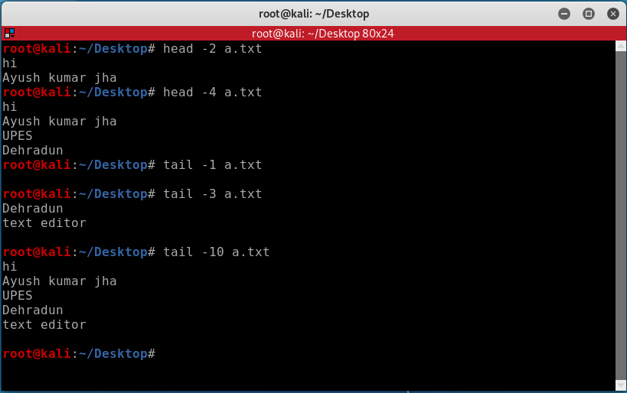

**3.Output Redirection-**

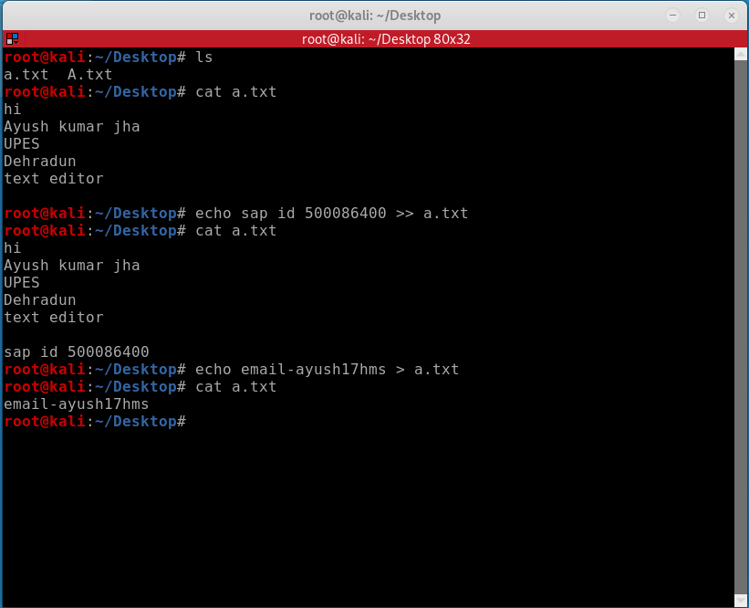

**4.Locate**

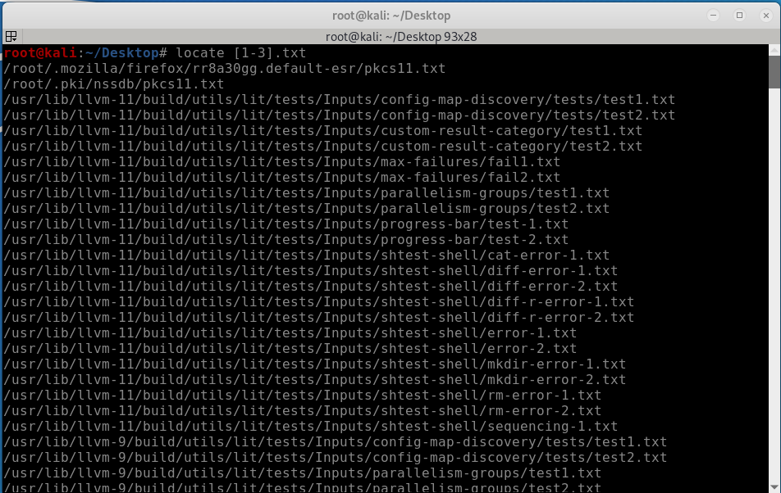

**5.Grep**

